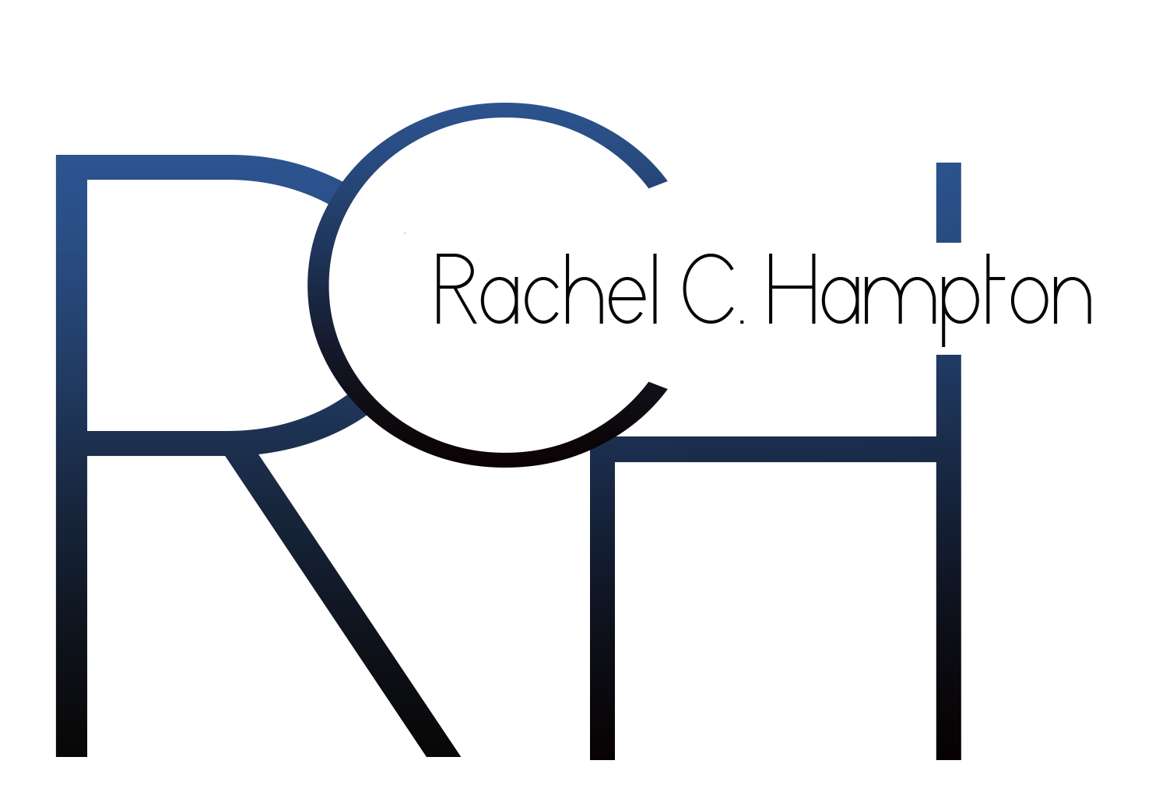

Rachel C. Hampton

RELEVANT EXPERIENCE
DEWDROP, LLC Social Media/Communications Intern
June ’12 – Present
- Shall work with create team to produce event themes, marketing materials, and event aesthetics
- Shall confirm media coverage and vendors for each event as well as develop a database of media contacts
- Shall create and publish press releases, blog posts, and promotions via social media and websites.

ReadyU PROCTER AND GAMBLE Campus Ambassador
September ’12 – Present
- Utilize guerilla marketing tactics and social media in order to create positive buzz about the company, products, and events
- Plan and implement programs and events to increase brand awareness
- Distribute Procter & Gamble products to Howard University campus and community

SPOTLIGHT NETWORK TV News Reporter/Web Contributor
September ‘12 - Present
- Develop and report packages concerning campus issues and happenings.
- Conduct interviews and create stories for the organization’ website.
- Report on news in the Washington, DC area.

HBCUBUZZ.COM Staff Writer
September ‘12- January ‘13
- Write and report stories as a Howard University campus representative.
- Contribute to the web department by developing stories on campus happenings.
- Serve as a liaison between the Howard community and HBCU Community

HOWARD UNIVERSITY HOMECOMING Media Department Volunteer
October ‘11
- Volunteered in the media department of Howard University Homecoming’s week-long series of events.
- Coordinated media relations and coverage of each event and ensured information was accessible to students and alumna via social networks such as Twitter, Facebook, and Hootsuite.
- Assured that media outlets were contacted about the events and permitted the outlets to cover them.

ADDITIONAL EXPERIENCE
EDUCATION FIRST TOURS: CULTURAL EXCHANGE – CHINA AND JAPAN
July ‘12-August ‘12
- Visited the following cities: Shanghai, China; Beijing, China; Tokyo, Japan; Hakone, Japan; Nikko, Japan
- Used this opportunity to immerse in Chinese and Japanese Cultures, study Western leadership models, serve as an international ambassador for Howard University, and learn more about opportunities overseas
- Highlights of the trip included: studying at the Normal University, networking at the World Financial Center, and participating in a cultural exchange with local students

ALTERNATIVE SPRING BREAK: ATLANTA – HOWARD UNIVERISTY
March ‘12
- Tutored and mentored 24 students of Toomer Elementary School within a poverty stricken area, Kirkwood, Georgia, for a week in order to prepare them for an upcoming standardized test for the state of Georgia
- Impacted elementary students' lives and enforced the importance of education and Historically Black Colleges and Universities by accompanying them on a trip to Morehouse and Spelman College campuses
- Volunteered for Books for Africa, an organization whose goal is to end the book famine in Africa by collecting, sorting, and shipping books to children in Africa.

EDUCATION
Howard University, Washington, DC
Expected Graduation: May 2015
Candidate for Bachelor of Arts
Major: Journalism – Broadcast News Minor: Spanish language

University of Granada, Granada, Spain
AIFS Study Abroad
Fall 2013

RELEVANT COURSE WORK
Journalism: Magazine Reporting and Writing
Journalism: Mass Communication
Journalism: Writing for the Media
Honors: Sophomore Research Seminar

SKILLS
Microsoft Office programming
Wordpress operations
Picasa Photo Editing
Social Media Proficiency

HONORS AND AWARDS
National Society of Collegiate Scholars Nomination
April ‘12
Walter H. Annenberg Honors Program Admittance
May ‘12
Freshman Leadership Academy Merit Award and Scholarship
May ‘12
Harriet Tubman Quadrangle Honor Society
May ‘12
School of Communications Dean’s List
May ‘12, December ’11,December ‘13
Golden Key Honour Society Nomination
November ‘11

AFFILIATIONS
T. Howard Foundation
Final Talent Pool member
January ‘13
Alpha Kappa Psi Professional Business Fraternity
Marketing Committee Member
November ‘12
Howard University Association of Black Journalists
Secretary
September ‘12
Freshman Leadership Academy
Past Participant and Current Mentor
October ‘11

